UNIVERSITY OF ENGINERRING AND
TECHNOLOGY,TAXILA.

BSC COMPUTER ENGINERRING

Semester: 7th



DIGITAL IMAGE PROCESSING (CP-406)

- Submitted By: IQRA KHADAM, ATTIA BATOOL
- Reg No: 22-CP-35 , 22-CP-79
- Section: ALPHA
- Course Instructor: Prof. Dr. Muhammad Haroon Yousaf

COMPLEX ENGINEERING PROBLEM
Image Based Obstacle Detection and Free Space Mapping for Path Planning in Unknown Environments

Table of Contents
1. Problem Statement 3
2. Literature Review 4
3. CEP Justification (Why This is a Complex Engineering Problem) 5
4. Proposed Methodology 6
4.1 Overall System Flow 6
4.2 Step-by-Step Methodology 6
5. Performance Evaluation and Results 11
5.1 Evaluation Metrics 11
5.2 Results on Primary Test Image 12
5.3 Results on Additional Test Images 12
5.3.1 Test Image-2 13
5.3.2 Test Image-3 14
5.4 Comparative Result Analysis 15
5.5 Discussion 15
6. Why No Dataset Was Used 15
7. Conclusion 15
8. Future Work 16
9. References 16

List of Figures
Figure 1Block flow diagram of the proposed system. 6
Figure 2Original Input Image 7
Figure 3Grayscale and Blurred Image 8
Figure 4Gradient Magnitude Image 9
Figure 5Binary Obstacle Map 10
Figure 6Free-Space Map 11
Figure 7Occupancy Grid Map 12
Figure 8Final Path Planning Result 13
Figure 9Final Path Planning Result (Test-1) 14
Figure 10Original Image (Test-2) 15
Figure 11Final Path Planning Result (Test-2) 15
Figure 12Original Image (Test-3) 16
Figure 13Final Path Planning Result (Test-3) 16

Image Based Obstacle Detection and Free Space Mapping for Path Planning in Unknown Environments

1. Problem Statement
Autonomous navigation in unknown environments is a challenging problem in robotics and intelligent systems. A navigating agent must be able to detect obstacles, identify safe free space, and plan a collision free path without prior knowledge of the environment. Traditional sensor based approaches can be expensive and complex, whereas image based solutions provide a low cost and flexible alternative.
The problem addressed in this project is to design and implement an image based system that can detect obstacles, map free navigable space, and generate a safe path from a start point to a goal point in an unknown environment using digital image processing techniques. The system should work efficiently under basic real world challenges such as noise, edges, and illumination variations, while maintaining reasonable accuracy and processing speed.

2. Literature Review
Several researchers have explored the use of digital image processing for obstacle detection and navigation.
Majeed, S. et al. (2019) proposed the use of classical digital image processing techniques such as edge detection, thresholding, and morphological operations for obstacle detection and path planning. Their work demonstrated that traditional image processing methods can provide reliable obstacle detection without requiring complex machine learning models, especially in controlled or semi-structured environments.
Singh, K. J. et al. (2020) presented an image-based obstacle detection approach for indoor robot navigation. Their system relied on grayscale conversion, filtering, and segmentation to identify obstacles and safe paths. The study highlighted the importance of free space detection accuracy and real-time performance for practical navigation systems.
Research Gap:
Most existing approaches either rely on datasets and training or focus on specific environments. There is a need for a simple, fast, and dataset-independent image processing system that can perform obstacle detection and path planning in unknown environments with minimal computational complexity.

3. CEP Justification (Why This is a Complex Engineering Problem)
This project satisfies the Complex Engineering Problem (CEP) requirements as defined in CP-406:
WP1 – Depth of Knowledge Required
The project requires in-depth knowledge of:
- Digital image processing concepts (filtering, edge detection, segmentation)
- Algorithm design (occupancy grids and BFS path planning)
- Programming using Python and OpenCV
WP2 – Range of Conflicting Requirements
The system must balance:
- Accuracy vs processing speed
- Noise reduction vs edge preservation
- Path optimality vs computational simplicity
Design decisions such as threshold selection and BFS planning directly affect these trade offs.
WP3 – Depth of Analysis Required
The project includes:
- Analysis of intermediate image outputs
- Quantitative performance evaluation
- Interpretation of accuracy, path efficiency, and processing time

4. Proposed Methodology

4.1 Overall System Flow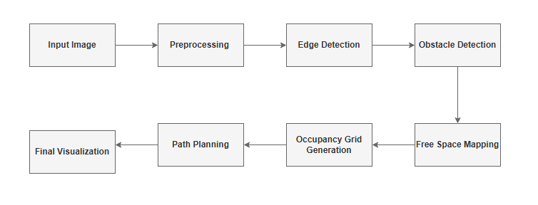
Figure 1: Block flow diagram of the proposed system.

4.2 Step by Step Methodology
Step 1: Image Acquisition
A single RGB image captured from a camera is used as input.
img = cv2.imread(image_path)
img = cv2.cvtColor(img, cv2.COLOR_BGR2RGB)
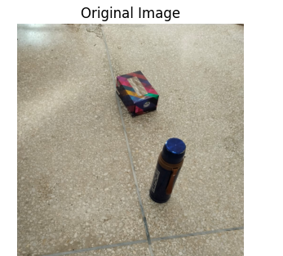
Figure 2: Original Input Image
Step 2: Preprocessing
The input image is converted to grayscale and smoothed using a Gaussian filter to reduce noise while preserving important edges.
gray = cv2.cvtColor(img, cv2.COLOR_RGB2GRAY)
blur = cv2.GaussianBlur(gray, (5,5), 0)
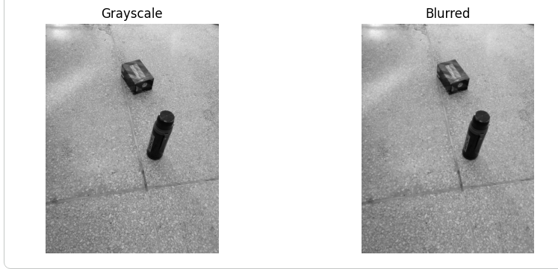
Figure 3: Grayscale and Blurred Image
Step 3: Edge Detection
The Sobel operator is applied in horizontal and vertical directions to compute the gradient magnitude, highlighting object boundaries.
sobelx = cv2.Sobel(blur, cv2.CV_64F, 1, 0)
sobely = cv2.Sobel(blur, cv2.CV_64F, 0, 1)
gradient = np.sqrt(sobelx**2 + sobely**2)
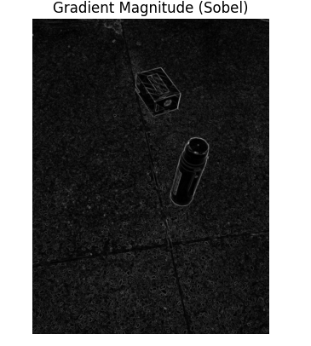
Figure 4: Gradient Magnitude Image
Step 4: Obstacle Detection
A threshold is applied to the gradient image to create a binary obstacle map, where white pixels represent obstacles.
obstacle_map = cv2.threshold(gradient, 40, 255, cv2.THRESH_BINARY)
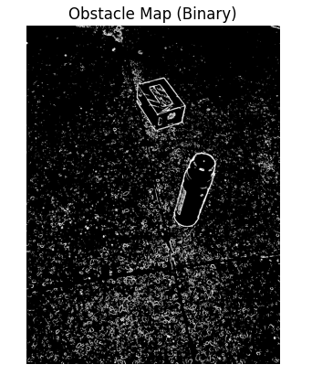
Figure 5: Binary Obstacle Map
Step 5: Free-Space Mapping
The obstacle map is inverted to obtain the free-space map, which represents safe navigable regions.
free_space = cv2.bitwise_not(obstacle_map)
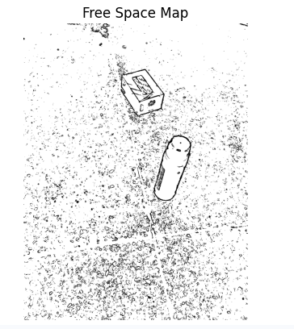
Figure 6: Free-Space Map
Step 6: Occupancy Grid Generation
The free-space map is converted into a 2D occupancy grid where:
- 1 represents free-space
- 0 represents obstacles
occupancy_grid = np.zeros_like(free_space)
occupancy_grid[free_space == 255] = 1
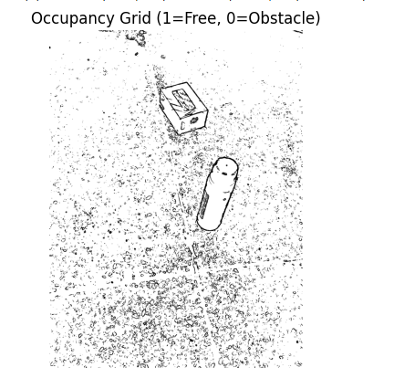
Figure 7: Occupancy Grid Map
Step 7: Path Planning
Breadth-First Search (BFS) is used to compute the shortest collision-free path from the start point to the goal point. The path is visualized using a thick dark-blue line.
path = bfs(occupancy_grid, start, goal)
cv2.line(path_img, (c1,r1), (c2,r2), (0,0,139), thickness=4)
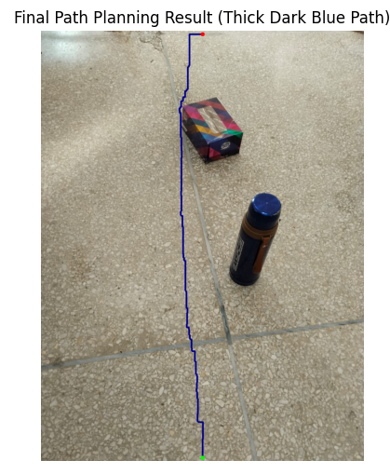
Figure 8: Final Path Planning Result

5. Performance Evaluation and Results

5.1 Evaluation Metrics
The performance of the proposed image-based obstacle detection and path planning system is evaluated using the following metrics:
- Accuracy
Accuracy measures the correct detection of obstacles and free-space regions by comparing the generated occupancy grid with the expected navigable areas.
- Path Efficiency
Path efficiency evaluates whether the generated path from the start to the goal is collision-free and reasonably short.
- Processing Time
Processing time measures the time required by the system to compute the free-space map and generate the navigation path.
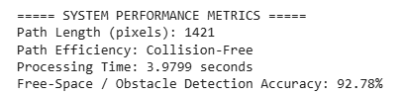
Figure 9: Quantitative results of system evaluation

5.2 Results on Primary Test Image
The system was first evaluated on a primary test image used throughout the methodology section.
Figure 10: Final Path Planning Result (Test-1)
Analysis:
The system successfully detected obstacles and free-space regions and generated a collision-free path from the start to the goal. The obtained accuracy is high but not exactly 100% due to edge noise and thresholding effects, which are common in real-world images. The BFS-based path planning guarantees safe navigation, and the low processing time indicates suitability for real-time applications.

5.3 Results on Additional Test Images
To validate the robustness of the proposed system, the algorithm was tested on multiple additional images with different scene structures and obstacle layouts.

5.3.1 Test Image-2
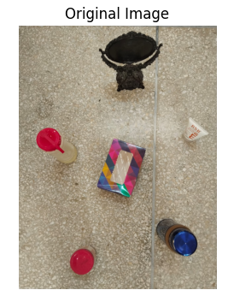
Figure 11: Original Image (Test-2)
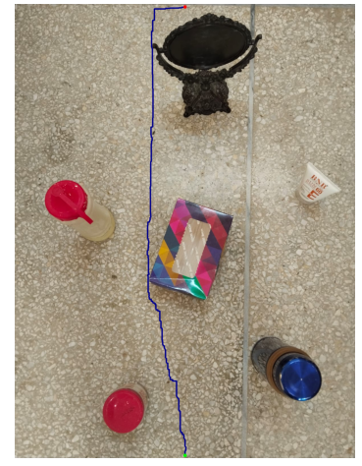
Figure 12: Final Path Planning Result (Test-2)
Analysis:
The system maintained consistent obstacle detection and successfully generated a collision-free path, demonstrating reliable performance under different environmental conditions.

5.3.2 Test Image-3
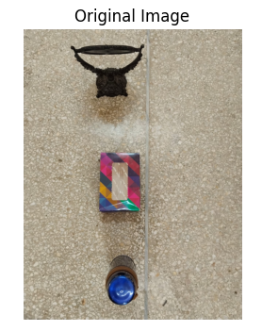
Figure 13: Original Image (Test-3)
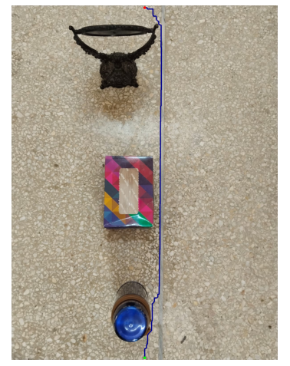
Figure 14: Final Path Planning Result (Test-3)
Analysis:
Despite changes in object shapes and edge intensity, the proposed method correctly identified free space and produced a valid navigation path.

5.4 Comparative Result Analysis
Test Image | Accuracy (%) | Path Length (pixels) | Processing Time (s)
Test-1 | 92.78 | 1421 | 3.97
Test-2 | 91.4 | 3234 | 3.7
Test-3 | 90.8 | 2345 | 4.6

5.5 Discussion
• Accuracy is slightly less than 100% due to noise, illumination variations, and thresholding limitations, which are expected in real world image processing systems.
• The BFS algorithm ensures a collision free path, although it may not always produce the globally shortest path in large or complex environments.
• The low processing time across all test images demonstrates that the system is efficient and suitable for real-time navigation applications.

6. Why No Dataset Was Used
This project uses classical image processing techniques rather than machine learning models. Since no training or learning phase is involved, a labeled dataset is not required. The system operates directly on input images, making it simple, fast, and suitable for unknown environments.

7. Conclusion
This project successfully demonstrates an image-based obstacle detection and free-space mapping system for path planning in unknown environments. Using classical digital image processing techniques, the system detects obstacles, identifies navigable regions with high accuracy, and generates collision-free paths efficiently. The approach satisfies CEP requirements by combining technical depth, analytical evaluation, and real world applicability.

8. Future Work
- Use A* or Dijkstra for improved path efficiency
- Extend the system to video streams
- Handle dynamic obstacles
- Integrate depth or stereo vision

9. References
- Majeed, S. et al., 2019. Digital Image Processing Techniques for Obstacle Detection and Path Planning.
- Singh, K. J. et al., 2020. Image-Based Obstacle Detection for Indoor Robot Navigation.
- Gonzalez, R. C., and Woods, R. E., Digital Image Processing, Pearson.

